1. **Doors TC to xlsx Template**

**How to use tool:**

Step1: Invoke given executable.

Step2: Select “1. Doors TC to xlsx Template”

Step3: It opens up the another window, there

press “Select file” to select the test case Excel document.

Excel document should be of type ‘xlsx’ or ‘xls’.

Step4: Press ‘Convert to Template’ button

Step5: If Conversion is successful then tool produces the results in

<SelectedFile>_<Template>.xlsx file (Results will be stored in Selected path). If there is any issue found during conversion, it will be logged into <SelectedFileName>.txt file.

**Note:** Execution Progress will be shown in command prompt.

**Excel Template constrains:**

1. Set, Verify and Configure formats

Set <Var name> to <value>

Verify <Var Name> is <Value>

Configure <var name> is <Value>

2. Wherever Set and Verify format does not match, then row number will be written into log file (user should correct the test case) and Test Case Object text will not be written into template.

3. Comment section for test case is not separated with time cycles, so entire comment section will be written into the initial step of the each test case.

4. File should be in format of *.xls or *.xlsx

5. Template file should not open (in which already results are produced)

6. Issues which are found in selected sheet will be listed in '<Selected xlsx file>.txt' file

7. Before time cycles of the test case there should not be any information

8. Doors format of TC should be in below format.

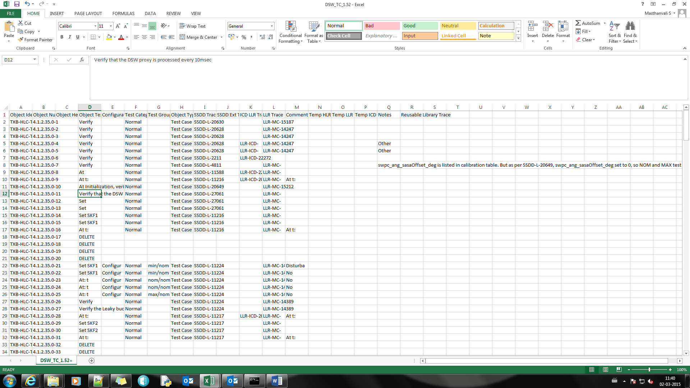

1. **TC Template to Doors**

**How to use tool:**

Step1: Invoke given executable and select “2. TC Template To Doors”

Step2: It opens up another window, press “Select file” to select the test

Procedure Excel document. Excel document should be of type

‘xlsx’ or ‘xls’.

Step3: Press ‘Run To Doors Format’ button.

Step4. If Conversion is successful then tool produces the results in

<SelectedFile>_<To_Doors>.xlsx file (Results will be stored in Selected path). If there is any issue found during conversion, it will be logged.

**Excel Template constrains:**

1. Template file should not open (in which already results are produced)
2. Doors format test case will be generated from first sheet of selected excel sheet.
3. Test step number should not be empty.
4. Inputs, output and calibration value names in sheet as follows
5. **Inputs** or **inputs** or **Intermediate inputs** or **intermediate Inputs** or **intermediate inputs** or **Intermediate Inputs**
6. **Outputs** or **outputs** or **Intermediate Outputs** or **intermediate Outputs** or **intermediate outputs**.
7. **calibration value**
8. Calibration values which are going to use in complete test step must be specified only at the first cycle of test step.
9. Test case format should be as follows

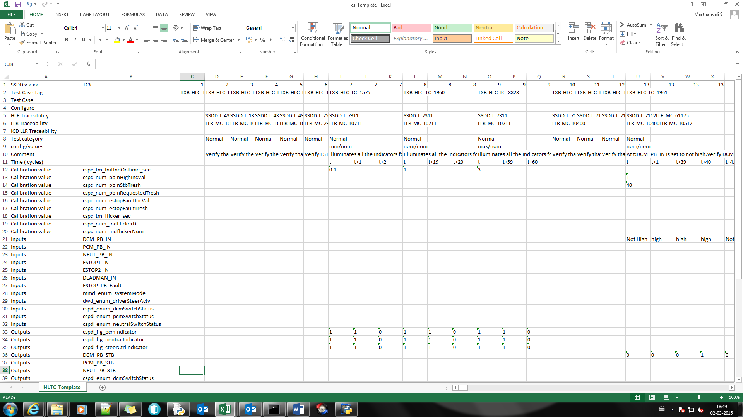

1. **Doors TP to xlsx Template:**

**How to use tool:**

Step1: Invoke given executable.

Step2: Select “3. Doors TP to xlsx Template”

Step3: It opens up the another window, there

Press “Select file” to select the test case Excel document.

Excel document should be of type ‘xlsx’ or ‘xls’.

Step4: Press ‘Convert to Template’ button

Step5: If Conversion is successful then tool produces the results in

<SelectedFile>_<Template>.xlsx file (Results will be stored in Selected path). If there is any issue found during conversion, it will be logged into DoorsTPIssues.txt file.

**Note:** Execution Progress will be shown in command prompt.

**Excel Template constrains:**

1. TP should consistently follow only one timing format for Set and Verify sections.
2. TP should not have setup cycles.
3. Doors format TP should not be empty.
4. TP should be in following format.

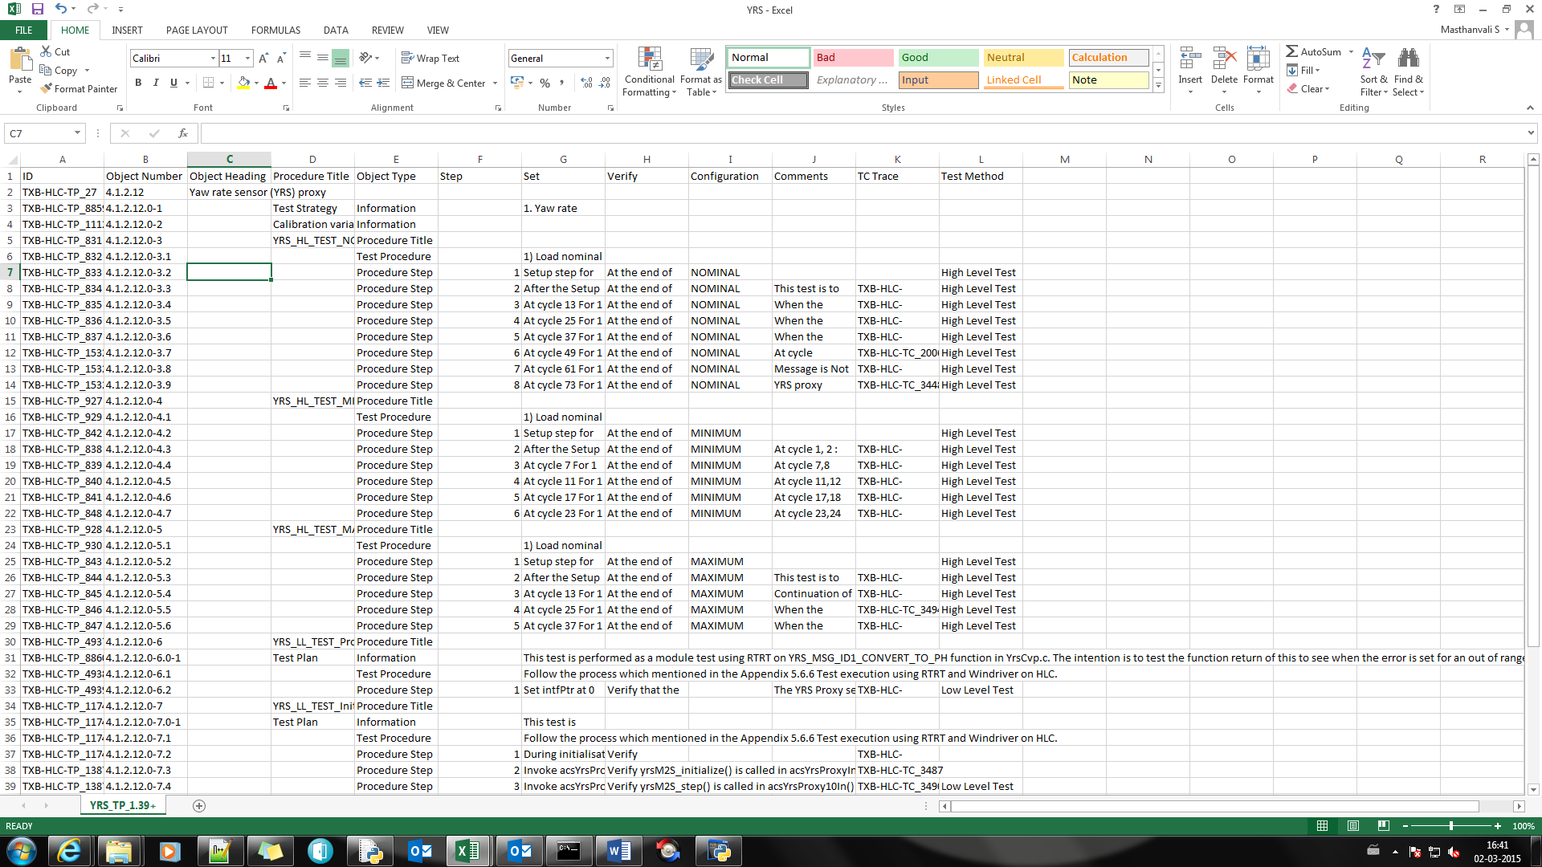

1. NOM, MAX and MIN test procedures should be separated with ‘HL_TEST’ procedure.
2. Template file should not open (in which already results are produced)
3. Doors test procedure should always be in first sheet.
4. Object type must be specified as **Procedure Step** for test steps.
5. Set formats:
6. At.*cycle.*[\d]+.*for.*[\d]+.*cycles
7. At.*[\d]+.*cycle.*For.*[\d]+.*cycles
8. At:.*[\d]+
9. Verify formats:
10. At.*the.*end.*of.*cycle.*[\d]+
11. At.*the.*end.*of.*[\d]+.*cycle
12. At:.*[\d]+
13. Comment format:
14. ^\s*At.*Cycle.*[\d]+\s*$
15. ^\s*At.*[\d]+.*Cycle\s*$
16. ^\s*At.*[\d]+\s*$
17. Number of Input and output verifications should match
18. If Set or Verify or comment section formats does not follow above points, then tool produces issues log and template might not have correct results. So first resolve TP issues and check test procedure template.
19. File should be in format of *.xls or *.xlsx
20. **TP Template to Doors**

**How to use tool:**

Step1: Invoke given executable.

Step2: Select “4. TP Template To Doors”

Step3: It opens up the another window, there

Press “Select file” to select the test case Excel document.

Excel document should be of type ‘xlsx’ or ‘xls’.

Step4: Now Enter system execution time (should be of type integer)

and Press ‘Run To Doors Format’ button.

Step5: If Conversion is successful then tool produces the results in

<SelectedFile>_<Template>.xlsx file (Results will be stored in Selected path). If there is any issue found during conversion, failures will be logged

**Note:** Execution Progress will be shown in command prompt.

**Excel Template constrains:**

1. Template file should not open (in which already results are produced)
2. Doors format test procedure will be generated from first sheet of selected excel sheet.
3. Test step number should not be empty.
4. Inputs and output names in sheet as follows
5. **Inputs** or **inputs**
6. **Outputs** or **outputs**
7. Template format should be as follows

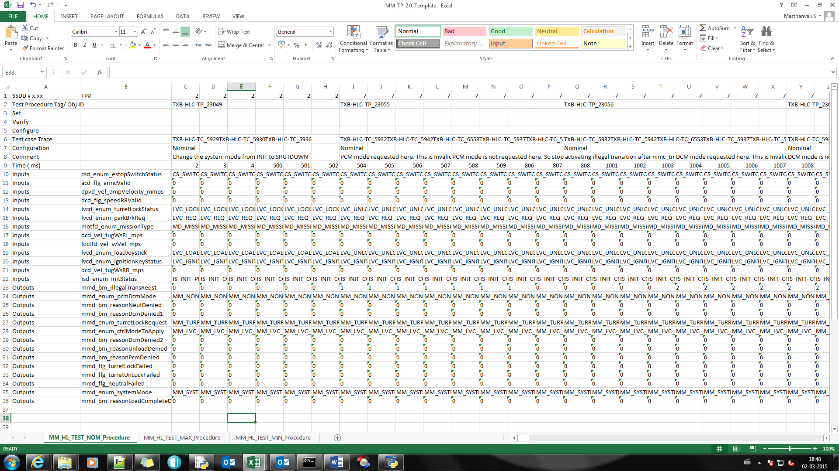

1. **TP to SIL Script**

**How to use tool:**

**Step1**: Invoke given executable.

**Step2**: Select “6. TP To SIL Script generator”

**Step3**: It opens up the another window, there

Press “Select file” to select the test case Excel document.

Excel document should be of type ‘xlsx’ or ‘xls’.

**Step4**: Now enter following details

1. TP Template sheet index
2. System execution time ()

Note: If TP is cycle based, then enter execution time 1 to 9 (depends on the time diff). If TP is timing based, then min execution time is 10.

1. SIL global request number
2. SIL execution start time

Then Press ‘Run Test’ button.

**Step5**: If Conversion is successful then tool produces the results in

<SelectedFile>_<HL_TEST>.txt file (Results will be stored in Selected path). If there is any issue found during conversion, failures will be logged in ‘TP_To_SIL_Script_Issues.txt’

**Note:** Execution Progress will be shown in command prompt.

**Excel Template constrains:**

1. From HLTP test Procedure delete Calibration values rows (keep only header section, Input and Output rows).

2. Please ensure that there is no content after outputs

3. If TP is cycle based, then enter execution time between 1 to 9 (depends on the time diff). If TP is timing based, then min execution time is 10.

4. TP template should be as configured

